**Project Proposal – Team 11**

Product Vision: Splatoon 2 but with cars

Feature List

|  |  |
| --- | --- |
| **Theme** | **ID: Features = Days** |
| Car Physics | 0: Make car go forward = 0.5  1: Make car accelerate, deccelerate = 0.5  2: Make friction on car = 1  3: Make wheels spin = 1  4: Make wheels turn from car angle = 1  5: Make car turn = 2  6: Knocking down obstacles = 2  7: GearBox - changing acceleration limit = 1  8: Power ups = 2 |
| Menus and UI | 9: Start Menu - Play and Quit = 2  10: Level Selection = 1  11: Timer = 1  12: Speed Gauge = 1  13: Reticle = 1  14: Results Screen = 1  15: Pause Menu - Quit and Resume = 2 |
| Paint Stuff | 16: Paint trail = 2  17: Different Paints like milo = 0.5  18: Area of Paint calculation = 3  *19: Paint shooting with fall-off = 1 (dropped)*  20: Collision Detection = 1  *21: Paint accumulation and viscosity = 3 (dropped)* |
| A.I. | 22: Path-based / Checkpoint-based / focus-based AI - it will go towards where there is no Paint of its type = 5  25: Map Generation = 2 |
| Framework Stuff | -: GameObjects - encapsulate rendering = N.A.  23: Scene Manager - Loading between different scenes = 1  24: Third-person Camera = 1  -: Encapsulate basically everything opengl (done in Terence’s slack) |
| Scenes / Levels | 26: Garage = 5  -: Menus and UI (see above) = N.A.  -: Level 1, with car and ink (compiled by anyone) = 0.1 |

Game UI controls description

|  |
| --- |
| Up arrow, Down arrow - accelerate, decelerate, brake car  Left arrow, Right arrow - steer car  X, Z - shift gears up/down  Mouse Click - Select in menu  Mouse Movement - Move reticle |

Task breakdown for each member and estimation for each feature

|  |  |
| --- | --- |
| Person | Feature |
| Faizal | Third-person Camera  **Path-based** / Checkpoint-based / focus-based AI - it will go towards where there is no Paint of its type  **Map Generation** |
| Ko Sand | **All of Car Physics**  **Results Screen** |
| Marcus | **Start Menu - Play and Quit**  Level Selection  Pause Menu - Quit and Resume  Reticle / Cursor  **Level 1**  **Power ups(Make the abstract class)** |
| Alex | **Garage**  Timer  Sound  Car hood customisation  Speed Gauge  **Power ups(helping populate with derived classes)**  3D modelling  Texturing |
| Terence | **Framework Stuff (**minus Third Person cam)  **Car Physics(helping)**  **Paint trail**  **Area of Paint calculation**  **Collision Detection**  **Collision Resolution** |

Project schedule(Planned pre-SP)

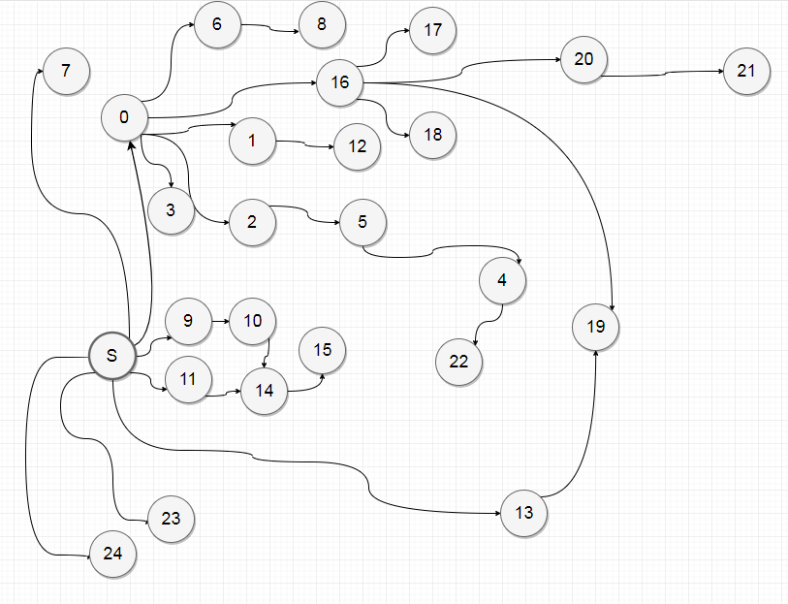

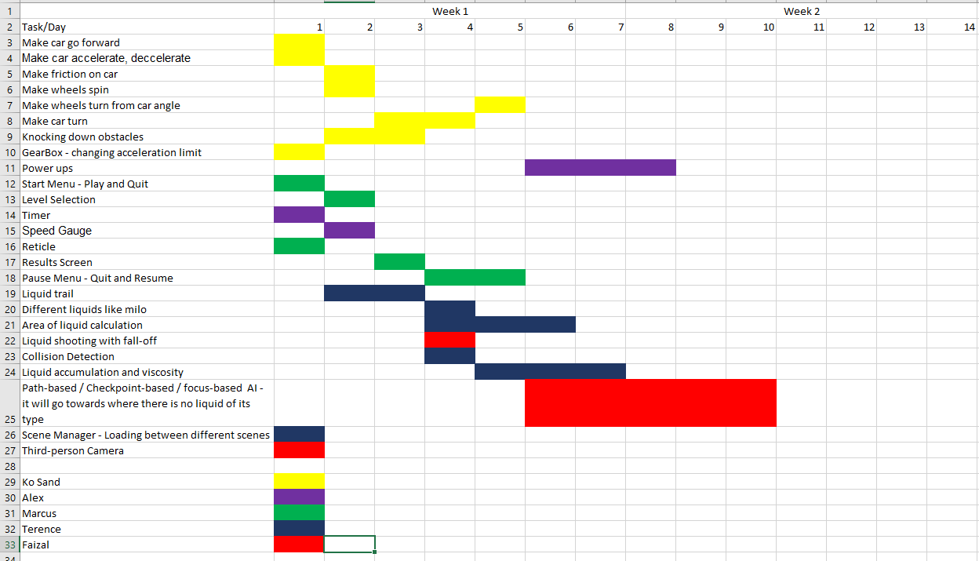

Project schedule week 2(Midway)

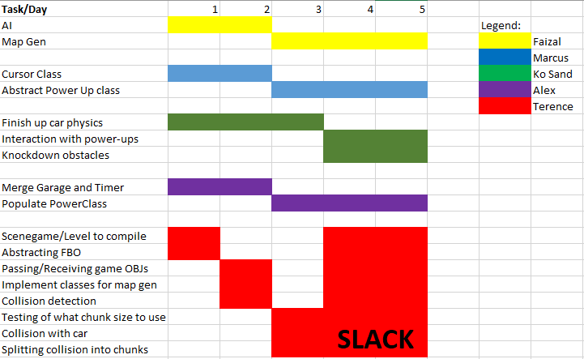

Unique selling points

|  |
| --- |
| Paintable surfaces  Realistic car physics  2D collision done with GJK and EPA |